

Semester Two Examination, 2018

Question/Answer booklet

MATHEMATICS

SOLUTIONS
METHODS
UNITS 1 AND 2

Section Two:

Calculator-assumed

Student number: In figures

In words

Your name

Time allowed for this section
Reading time before commencing work: ten minutes
Working time: one hundred minutes

Materials required/recommended for this section
To be provided by the supervisor
This Question/Answer booklet
Formula sheet (retained from Section One)

To be provided by the candidate
Standard items: pens (blue/black preferred), pencils (including coloured), sharpener,
correction fluid/tape, eraser, ruler, highlighters

Special items: drawing instruments, templates, notes on two unfolded sheets of A4 paper, and up to three calculators approved for use in this examination

Important note to candidates
No other items may be taken into the examination room. It is your responsibility to ensure that you do not have any unauthorised material. If you have any unauthorised material with you, hand it to the supervisor before reading any further.

Structure of this paper

Section | Number of questions available | Number of questions to be answered | Working  time (minutes) | Marks available | Percentage of examination
Section One:  Calculator-free | 8 | 8 | 50 | 52 | 35
Section Two:  Calculator-assumed | 13 | 13 | 100 | 98 | 65
 |  |  |  | Total | 100

Instructions to candidates

1. The rules for the conduct of examinations are detailed in the school handbook. Sitting this examination implies that you agree to abide by these rules.

2. Write your answers in this Question/Answer booklet.

3. You must be careful to confine your response to the specific question asked and to follow any instructions that are specified to a particular question.

4. Supplementary pages for the use of planning/continuing your answer to a question
have been provided at the end of this Question/Answer booklet. If you use these pages to continue an answer, indicate at the original answer where the answer is continued, i.e. give the page number.

5. Show all your working clearly. Your working should be in sufficient detail to allow your answers to be checked readily and for marks to be awarded for reasoning. Incorrect answers given without supporting reasoning cannot be allocated any marks. For any question or part question worth more than two marks, valid working or justification is required to receive full marks. If you repeat any question, ensure that you cancel the answer you do not wish to have marked.

6. It is recommended that you do not use pencil, except in diagrams.

7. The Formula sheet is not to be handed in with your Question/Answer booklet.

Section Two: Calculator-assumed 65% (98 Marks)
This section has thirteen (13) questions. Answer all questions. Write your answers in the spaces provided.

Working time: 100 minutes.

Question 9 (6 marks)
(a) A sequence is defined by $T_{n+1}=T_{n}-1.8, T_{1}=975$. Determine

(i) the value of $T_{120}$. (1 mark)
Solution
$$T_{120}=760.8$$

Specific behaviours
correct value

(ii) the sum of the first $120$ terms of this sequence. (2 marks)
Solution
$$S_{120}=\frac{120}{2}×\left(975+760.8\right) \\ =104 148$$

Specific behaviours
uses sum formula
✓ correct sum

(b) Another sequence is defined by $T_{n}=975{\left(0.2\right)}^{n-1}.$ Determine

(i) the value of $T_{5}$. (1 mark)
Solution
$$T_{5}=1.56$$

Specific behaviours
correct value

(ii) the value $S_{n}$ approaches as $n→∞$. (2 marks)
Solution
$$S_{∞}=\frac{975}{1-0.2} \\ =1 218.75$$

Specific behaviours
uses sum to infinity formula
✓ correct value

Question 10 (6 marks)
The variables $x$ and $y$ are related by the equation $2x+5y=15$.

(a) Sketch the graph of this relationship. (2 marks)

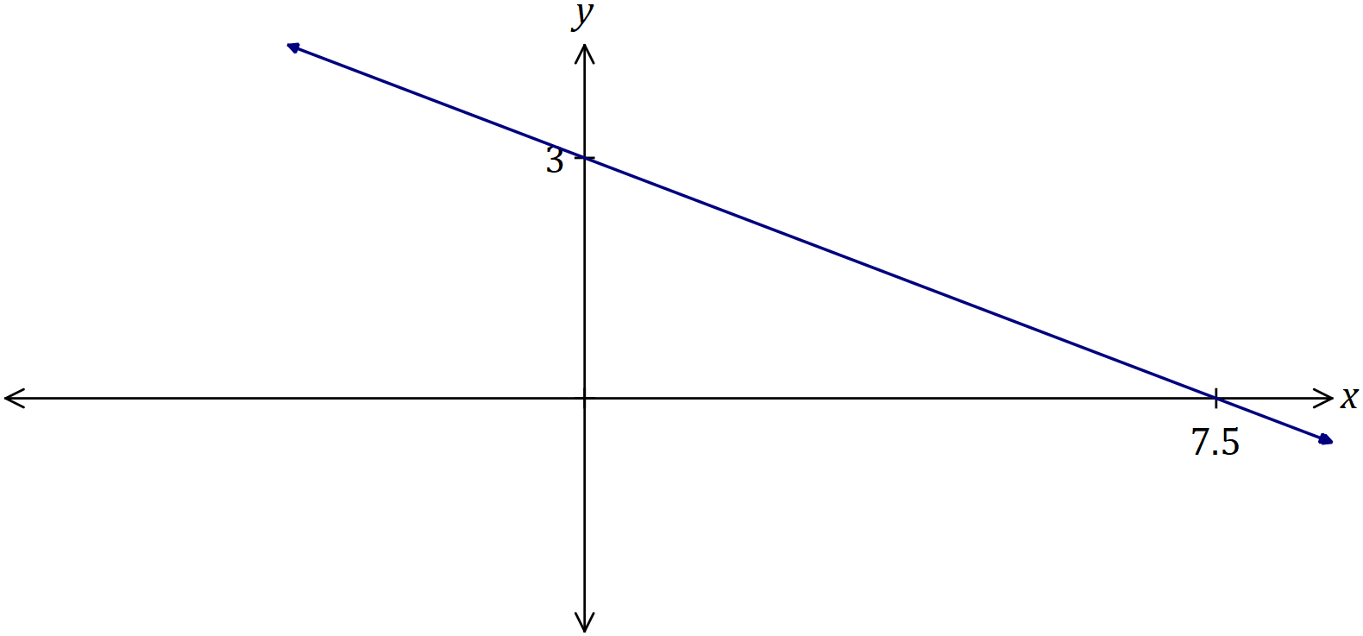
Solution
See graph
Specific behaviours
$y$-intercept of line
✓ $x$-intercept of line

(b) Express $y$ in terms of $x$ and briefly explain why $y$ is a function of $x$. (2 marks)
Solution
$$y=3-\frac{2}{5}x$$

For each $x$ value there is just one $y$ value, so one-to-one relationship.

Specific behaviours
correct rule
✓ indicates use of vertical line test or 'one-to-one' relationship

(c) The domain of $x$ is restricted to $-5≤x<10$. State the range of $y$. (2 marks)
Solution
$$x=-5, y=5, x=10, y=-1$$

$$-1<y≤5$$

Specific behaviours
correct values
✓ correct inequalities

Question 11 (9 marks)
The temperature $T$ of a cast taken out of an oven cools according to the model $T=840{\left(0.94\right)}^{t}$, where $t$ is the time in minutes since the cast was removed from the oven. $T$ is measured in $°C$.

(a) Determine the fall in temperature of the cast during the first $5$ minutes. (2 marks)
Solution
$$T=840{\left(0.94\right)}^{5}≈616°C$$
$$∆T=840-616=224°C$$

Specific behaviours
✓ value of $T$ when $t=5$
correct drop

(b) Graph the temperature of the cast against time on the axes below. (4 marks)

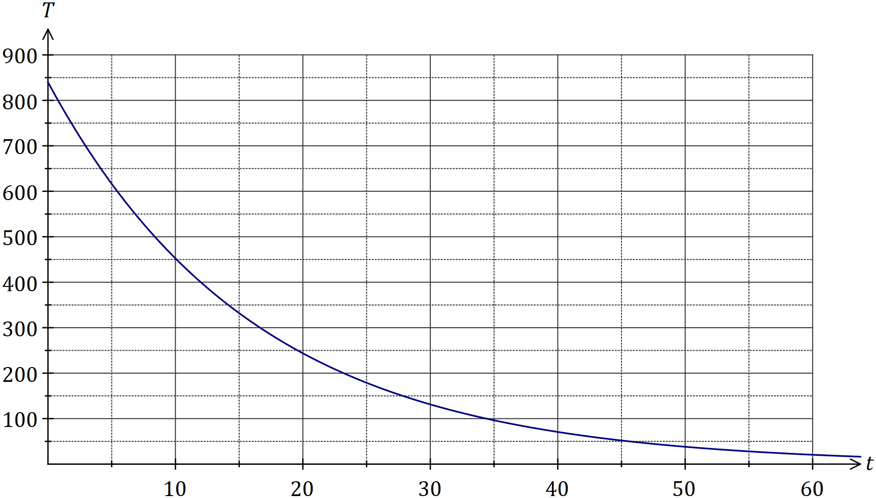
Solution
See graph
Specific behaviours
$y$-intercept
✓ close to $(20, 250)$ and $(45, 50)$
✓ smooth curve throughout
✓ no upward 'hook' at RHS

(c) State the name of this type of function. (1 mark)
Solution
Exponential.

Specific behaviours
correct name

(d) The temperature of the cast falls to room temperature of$15°C$.

(i) Determine the time taken for the cast to reach room temperature. (1 mark)
Solution
$$840{\left(0.94\right)}^{t}=15⇒t=65.1 \text{m}$$

Specific behaviours
correct time

(ii) Comment on the usefulness of the model for large values of $t$. (1 mark)
Solution
For large values of $t$ the model shows that $T→0$ but the temperature of the cast only falls to $15°C$ and so model not valid for large $T$.

Specific behaviours
states not valid, with reason

Question 12 (8 marks)
(a) Calculate the area of the minor segment that subtends an arc of $72°$ in a circle of diameter $170$ cm. (2 marks)
Solution
$$72°=\frac{2π}{5}, r=\frac{170}{2}=85$$

$$A=\frac{1}{2}{\left(85\right)}^{2}\left(\frac{2π}{5}-\sin{\frac{2π}{5}}\right)≈1 104 {\text{cm}}^{2}$$

Specific behaviours
converts angle, uses correct radius
✓ calculates area

(b) A chord of length $26$ cm subtends an angle of $\begin{matrix}π \\ \overline{17}\end{matrix}$ at the centre of a circle. Calculate the radius of the circle. (2 marks)
Solution
$$26=2r\sin\left(\frac{1}{2}×\frac{π}{17}\right)$$
$$r≈141 \text{cm}$$

Specific behaviours
substitutes into formula
✓ calculates radius

(c) Parallelogram $PQRS$ has side $PQ=28$ cm, side $PS=19$ cm and an area of $400$ cm². Determine the lengths of the diagonals of $PQRS$. (4 marks)
Solution
$$\frac{1}{2}\left(28\right)\left(19\right)\sin{x}=\frac{400}{2}$$

$$x=48.75°, 131.25°$$

$$L_{1}=\sqrt{{28}^{2}+{19}^{2}-2\left(28\right)\left(19\right)\cos{48.75}} \\ ≈21.1 \text{cm}$$

$$L_{2}=\sqrt{{28}^{2}+{19}^{2}-2\left(28\right)\left(19\right)\cos{131.25}} \\ ≈43.0 \text{cm}$$

Specific behaviours
equation for half area
✓ both angles of parallelogram
✓ correct length of one diagonal
✓ second correct length

Question 13 (8 marks)
A mobile phone retailer classified recent sales of $625$ phones by the age of customer and if the phone was bought outright or on a plan. A summary of the data is shown in the table below.

 | Aged under 30 | Aged 30 or over | Total
Bought outright | $$108$$ | $$p$$ | $$232$$
Bought on a plan | $$q$$ | $$152$$ | $$r$$
Total |  |  | $$625$$

(a) Determine the values of $p, q$ and $r$ shown in the table. (3 marks)
Solution
$$p=232-108=124$$

$$r=625-232=393$$

$$q=393-152=241$$

Specific behaviours
each correct value

(b) A recent sale is selected at random from those recorded above. Event $A$ occurs if the customer was aged under 30 and event $B$ occurs if the phone was bought outright. Determine the following probabilities:

(i) $P(\overline{B})$. (1 mark)
Solution
$$P\left(\overline{B}\right)=\frac{393}{625} (=0.6288)$$

Specific behaviours
correct probability

(ii) $P(B∪A)$. (1 mark)
Solution
$$P\left(B∪A\right)=\frac{625-152}{625}=\frac{473}{625} (=0.7568)$$

Specific behaviours
correct probability

(iii) $P(\overline{A}∩B)$. (1 mark)
Solution
$$P\left(\overline{A}∩B\right)=\frac{124}{625} (=0.1984)$$

Specific behaviours
correct probability

(iv) $P(A |\overline{B} )$. (2 marks)
Solution
$$P\left(A | \overline{B} \right)=\frac{241}{393} (≈0.613)$$

Specific behaviours
numerator
✓ denominator

Question 14 (7 marks)
A function is defined by $f\left(x\right)=\begin{matrix}x^{4} \\ \overline{ 4 }\end{matrix}-x^{3}$.

(a) Use the derivative $f'(x)$ to determine the coordinates of all stationary points of the function. (3 marks)
Solution
$$f^{'}\left(x\right)=x^{3}-3x^{2}$$

$$x^{3}-3x^{2}=0⇒x=0, x=3$$

$$f\left(0\right)=0, f\left(3\right)=-6.75$$

Stationary points at $\left(0, 0\right)$ and $\left(3, -6.75\right)$

Specific behaviours
correct derivative
✓ correct zeros of derivative
✓ correct coordinates

(b) Sketch the graph of $y=f(x)$ on the axes below. (4 marks)

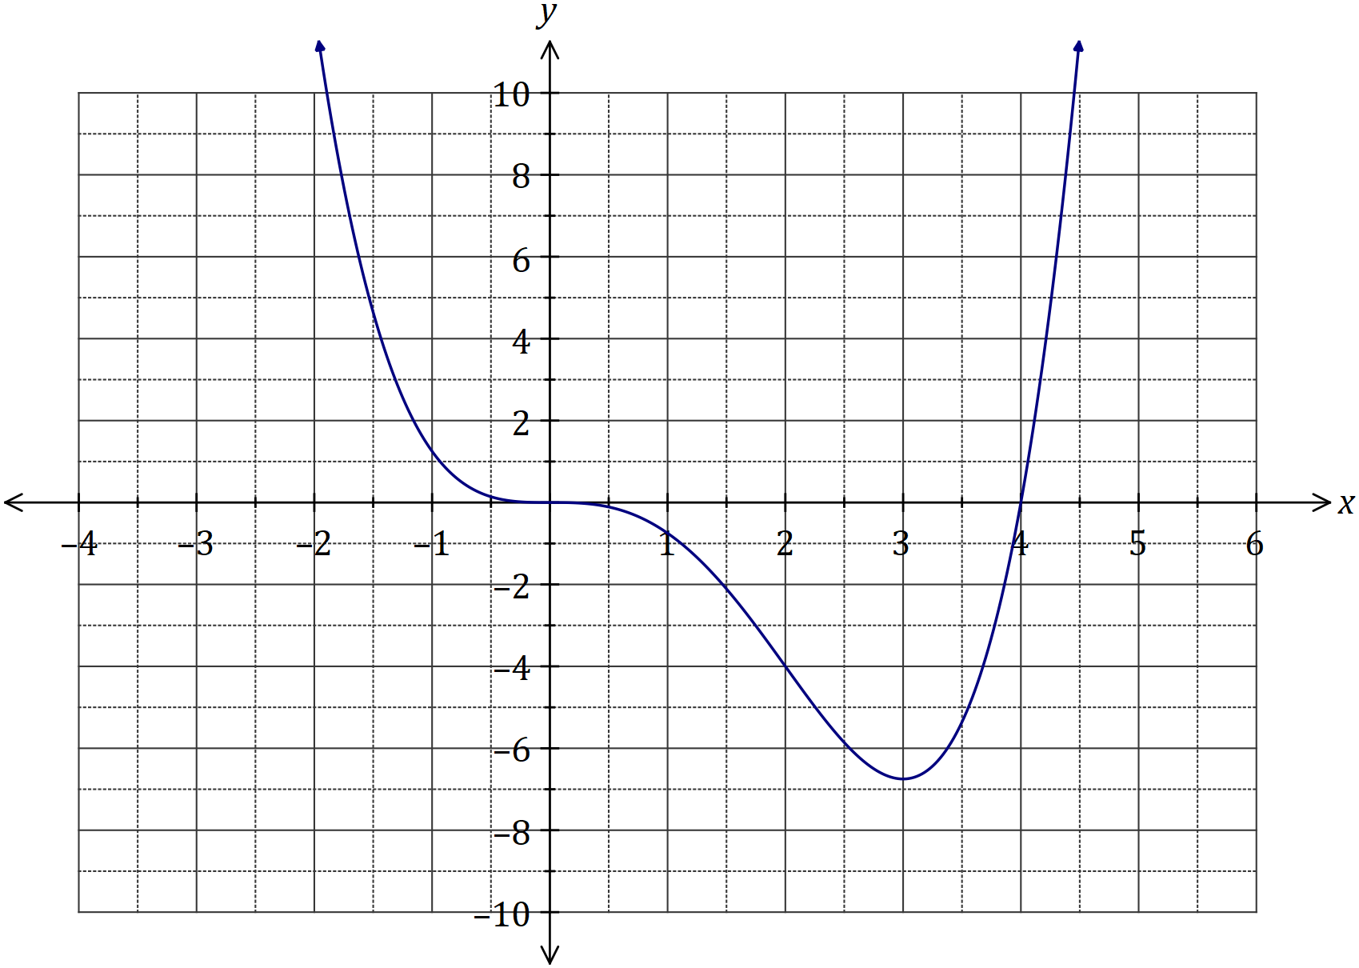
Solution
See graph
Specific behaviours
HPI at (0, 0)
✓ minimum at $\left(3, -6.75\right)$
✓ root at $\left(4, 0\right)$
✓ correct curvature

Question 15 (7 marks)
(a) The graph of $y=\sin{x}$ is shown below. On the same axes, sketch $y=\sin{2x}$. (2 marks)

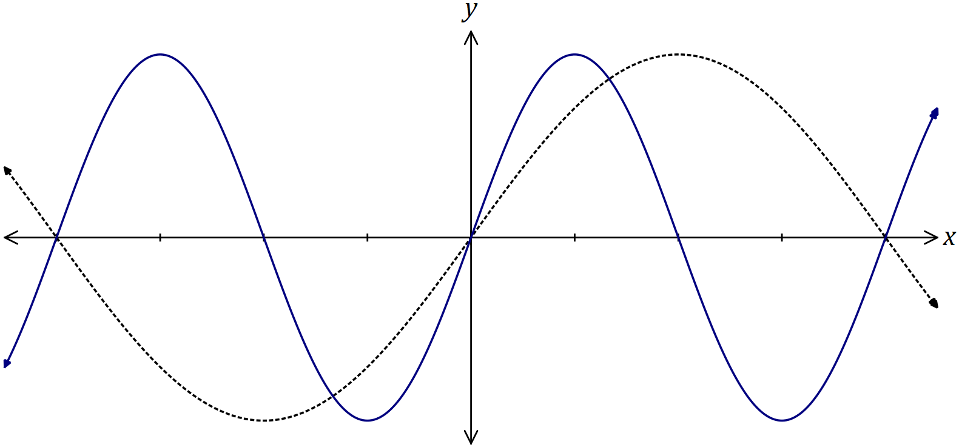
Solution
See graph
Specific behaviours
location of roots
✓ correct amplitude/shape

(b) The graph of $y=\tan{x}$ is shown below. On the same axes, sketch $y=\tan\left(x-\frac{π}{4}\right)$, and all its asymptotes. (3 marks)
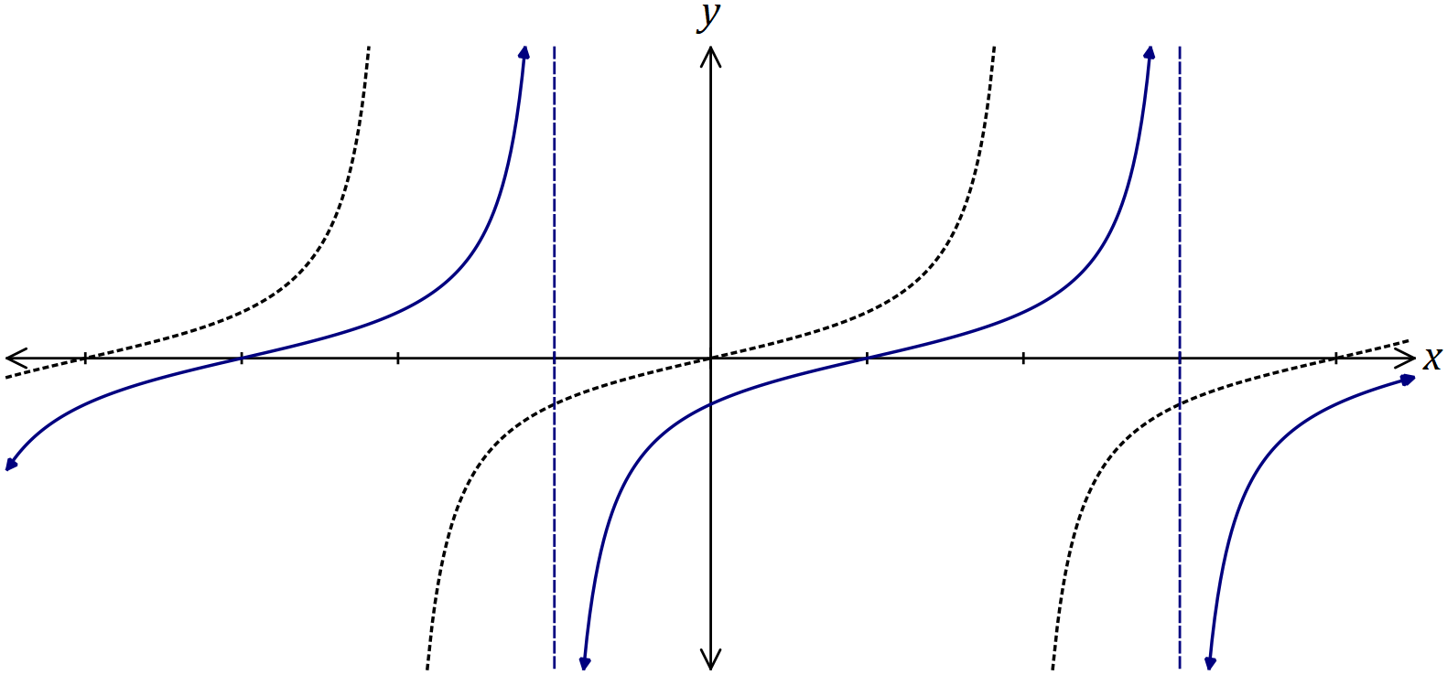
Solution
See graph
Specific behaviours
translation
✓ location of roots
✓ asymptotes

(c) The graph of $y=\cos{x}$ is shown below. On the same axes, sketch $y=\frac{1}{2}\sin\left(x+\frac{π}{2}\right)$.
(2 marks)
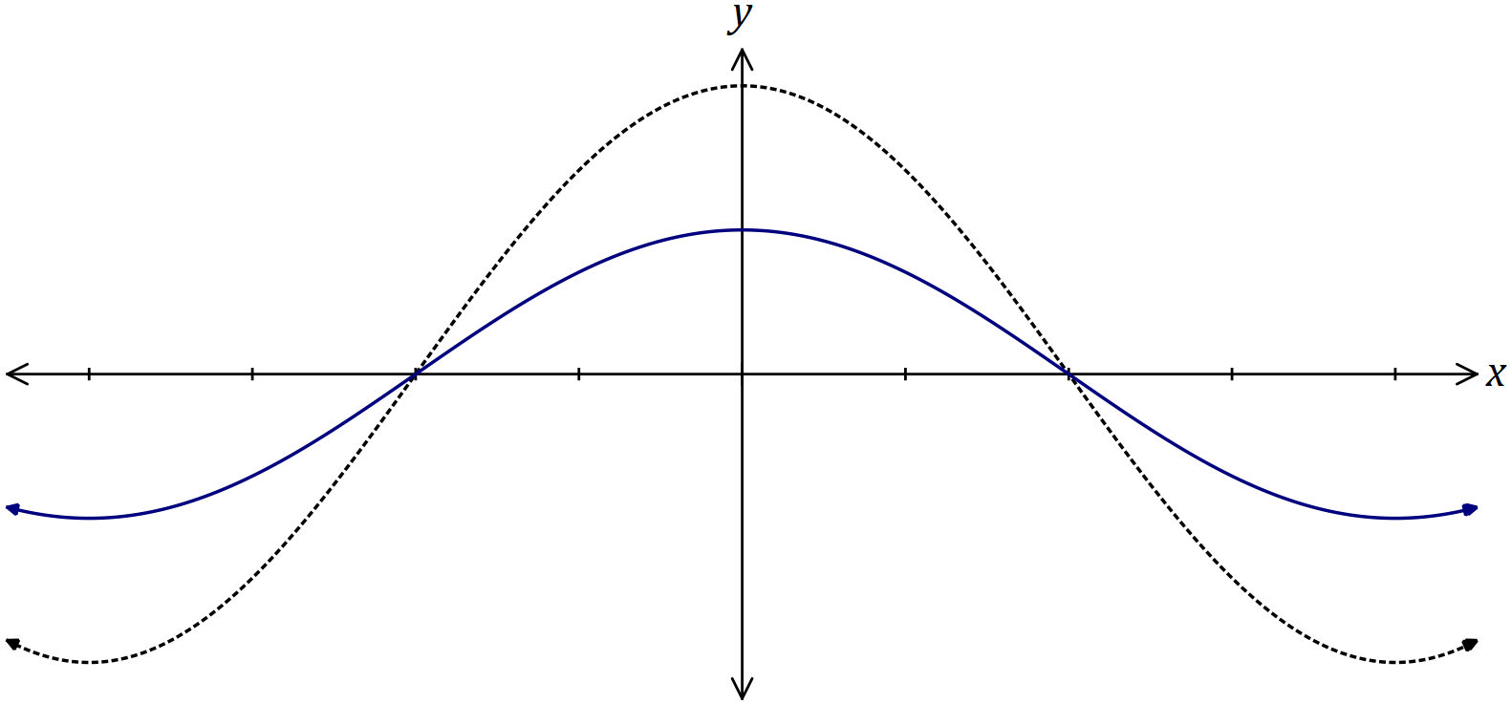
Solution
See graph
Specific behaviours
location of roots
✓ correct amplitude/shape

Question 16 (8 marks)
A council took a random sample of $154$ and $127$ properties from suburbs $A$ and $B$ respectively. A total of $49$ of the properties in the sample were in arrears with their rates, and $27$ of these properties were in suburb $A$. 'In arrears' means that payment of rates is overdue.

(a) Council officers wanted to choose $5$ of the properties that were in arrears. How many different selections of properties are possible? (2 marks)
Solution
$$\left(\begin{matrix}49 \\ 5\end{matrix}\right)=1 906 884$$

Specific behaviours
indicates use of $nCr$ formula
✓ correct number

(b) Determine the probability that one randomly chosen property from the sample

(i) is in suburb $B$ and is in arrears. (2 marks)
Solution
$$P=\frac{49-27}{154+127}=\frac{22}{281} (≈0.078)$$

Specific behaviours
numerator
✓ denominator

(ii) is not in arrears given that it is in suburb $A$. (1 mark)
Solution
$$P=\frac{154-27}{154}=\frac{127}{154} \left(≈0.825\right)$$

Specific behaviours
correct probability

(c) Justifying your answer with conditional probabilities, comment on whether being in arrears with rates is independent of the suburb the property is in. (3 marks)
Solution
$$P\left(\text{Arrears} | A\right)=\frac{27}{154}≈17.5\%$$

$$P\left(\text{Arrears|}B\right)=\frac{22}{127}≈17.3\%$$

Hence being in arrears is independent of suburb, as conditional probabilities are very similar.

Specific behaviours
✓ calculates $P\left(\text{Arrears} | A\right)$
calculates $P\left(\text{Arrears|}B\right)$
✓ correct conclusion

Question 17 (8 marks)
Two water containers, initially empty, are being filled with water. The amount of water added to container $A$ each minute follows an arithmetic sequence, with $3$ mL poured in during the first minute and $6$ mL poured in during the second minute. The amount of water added to container $B$ each minute follows a geometric sequence, with $2$ mL poured in during the first minute and $2.2$ mL poured in during the second minute.

(a) The amount of water poured into container $B$ during the $n^{th}$ minute is given by $a{\left(r\right)}^{n-1}$. State the value of the constants $a$ and $r$. (2 marks)
Solution
$$a=2 \\ r=\frac{2.2}{2}=1.1$$

Specific behaviours
value of $a$
✓ value of $r$

(b) Determine the total amount of water in container $B$ at the end of the ${25}^{th}$ minute.
(2 marks)
Solution
$$S_{25}=\frac{2{\left(1-{1.1}^{25}\right)}^{ }}{1-1.1}$$
$$=197 \text{mL}$$

Specific behaviours
uses sum formula
✓ correct amount

(c) How long does it take to fill container $A$ with $360$ mL of water? (2 marks)
Solution
$$\frac{n}{2}\left(2\left(3\right)+\left(n-1\right)\left(3\right)\right)=360$$
$$n=15 \text{minutes}$$

Specific behaviours
uses sum formula
✓ correct time

(d) Container $B$ first holds more water than container $A$ at the end of minute $m$.

(i) Determine the value of $m$. (1 mark)
Solution
$$m=59$$

Specific behaviours
correct value

(ii) State, to the nearest mL, how much more water $B$ contains than $A$ at this time.
(1 mark)
Solution
$$5516-5310=206 \text{mL}$$

Specific behaviours
correct value

Question 18 (8 marks)
The height, $h$ metres, above level ground of a seat on a steadily rotating Ferris wheel $t$ seconds after observations began was given by

$$h=6.5\cos\left(\frac{πt}{25}\right)+8, t≥0.$$

(a) Draw the graph of the height of the seat against time on the axes below. (4 marks)

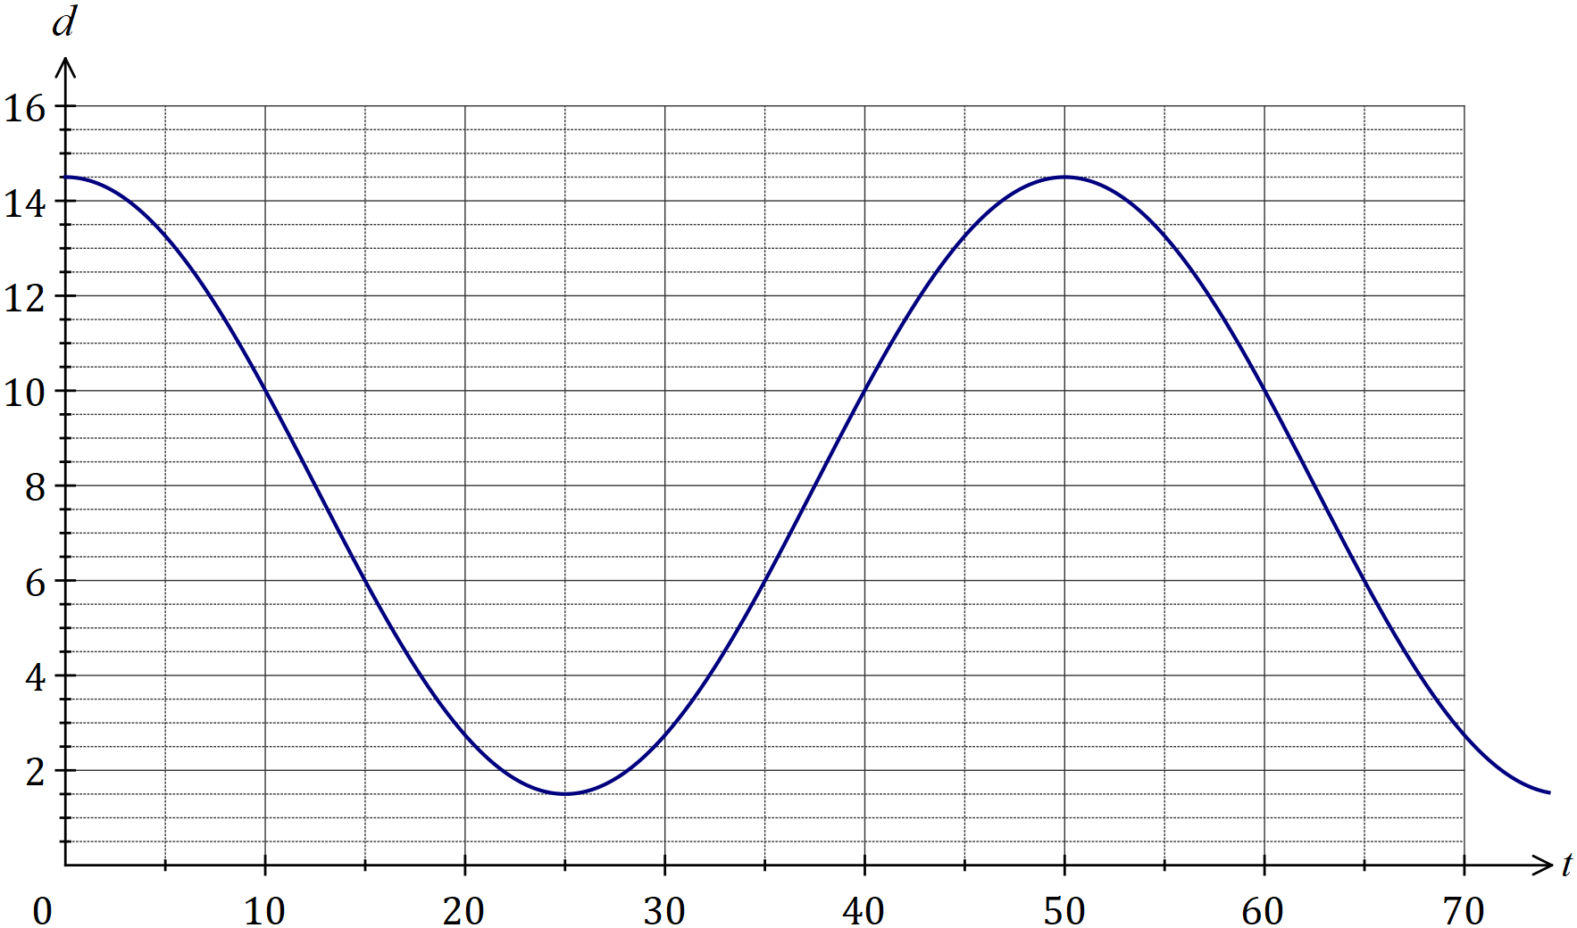
Solution
See graph
Specific behaviours
✓ correct $y$-intercept
accurate curve near maximum
accurate curve near minimum
smooth curve throughout

(b) How long did the Ferris wheel take to complete one revolution? (1 mark)
Solution
$$50 \text{seconds}$$

Specific behaviours
correct time

(c) At what time, when the seat was rising, did it first reach a height of $11$ metres? (1 mark)
Solution
$$t=41.3 \text{s}$$

Specific behaviours
time that rounds to $41 \text{s}$

(d) Determine the change in height of the seat between $t=130$ and $t=131$, giving your answer rounded to the nearest cm. (2 marks)
Solution
$$h\left(130\right)=2.74, h\left(131\right)=3.26$$

$$δh=3.26-2.74=0.52 \text{m}$$

Specific behaviours
determines both heights
states difference to nearest cm

Question 19 (7 marks)
(a) Part of the circle $x^{2}+y^{2}=ax+by+c$ is shown below. Determine the values of the constants $a, b$ and $c$. (4 marks)
Solution
See graph
Specific behaviours
tangent drawn with ruler

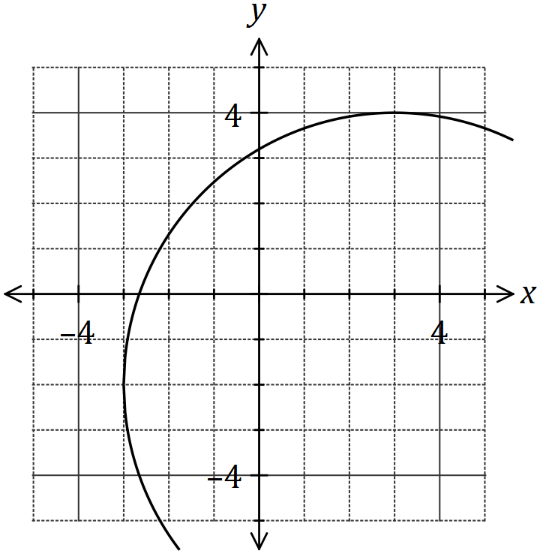
Solution
$${\left(x-3\right)}^{2}+{\left(y+2\right)}^{2}=6^{2}$$

$$x^{2}+y^{2}=6x-4y+23$$

$$a=6, b=-4, c=23$$

Specific behaviours
circle in factored form
✓ correct radius and centre
✓ expands into required form
✓ correct values of $a, b$ and $c$

(b) The graph of a power function $y=g\left(x\right)$ is shown below.

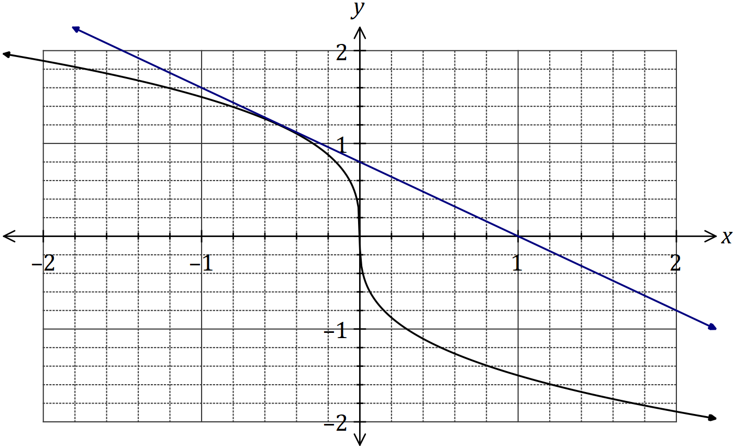

(i) Draw the tangent to the curve when $x=-0.5$. (1 mark)

(ii) Use the tangent to estimate $g'(-0.5)$. (2 marks)
Solution
$$g^{'}\left(-0.5\right)≈-\frac{1.6}{2}≈-0.8$$

Specific behaviours
uses gradient of tangent
✓ value $-1≤m≤-0.7$

Question 20 (8 marks)
A diagnostic test for a disease has a $97\%$ chance of giving the correct outcome and it is known that $0.5\%$ of all sheep on a station have the disease. It can be assumed that the correct outcome of the test is independent of whether a sheep has the disease.

(a) A sheep is randomly selected for the test from those on the station. Determine the probability that

(i) the sheep has the disease, but the test indicates that it does not. (2 marks)
Solution
$$P=0.005×0.03=\frac{3}{20 000}=0.000 15$$

Specific behaviours
indicates multiplication of correct probabilities
✓ correct probability

(ii) the sheep actually has the disease if the test indicates that it does. (4 marks)
Solution
$$P\left(D∩T\right)=0.005×0.97=0.00485 \\ P\left(\overline{D}∩T\right)=0.995×0.03=0.02985 \\ P\left(T\right)=0.00485+0.02985=0.0347 \\ P\left(D | T\right)=\frac{0.00485}{0.0347}=\frac{97}{694}≈0.140$$

Specific behaviours
calculates $P\left(D∩T\right)$
calculates $P\left(\overline{D}∩T\right)$
✓ indicates $P\left(T\right)$
✓ correct probability

(b) Two sheep are randomly selected for the test from those on the station. Determine the probability that just one of the sheep is diagnosed correctly. (2 marks)
Solution
$$P\left(S_{1}∩\overline{S_{2}}\right)=0.97×0.03=0.0291 \\ P\left(\overline{S_{1}}∩S_{2}\right)=0.03×0.97=0.0291 \\ P=0.0291+0.0291 \\ =0.058 2$$

Specific behaviours
indicates correct method
✓ correct probability

Question 21 (8 marks)
A pyramid with a rectangular base of length $L$ and width $w$ has perpendicular height $h$. The length of the base is three times its width and the sum of the width, length and height is $180$ cm.

(a) Calculate the length, height and volume of the pyramid when $w=15$ cm. (2 marks)
Solution
$$L=3×15=45, h=180-15-45=120$$

$$V=\frac{1}{3}\left(15×45\right)×120=27 000 {\text{cm}}^{3}$$

Specific behaviours
correct length and height
✓ correct volume

(b) Show that the volume of the pyramid is given by $V=180w^{2}-4w^{3}$. (2 marks)
Solution
$$L=3w, h=180-w-3w=180-4w$$

$$V=\frac{1}{3}\left(w×3w\right)\left(180-4w\right) \\ =180w^{2}-4w^{3}$$

Specific behaviours
expressions for length and height
✓ substitutes width, length and height correctly

(c) Use calculus to determine the maximum volume of the pyramid and state the dimensions required to achieve this volume. (4 marks)
Solution
$$\frac{dV}{dw}=360w-12w^{2}$$

$$360w-12w^{2}=0⇒w=0, 30$$

$$V_{max}=180{\left(30\right)}^{2}-4{\left(30\right)}^{3}=54 000 {\text{cm}}^{3}$$

$$w=30 \text{cm}, L=90 \text{cm}, h=60 \text{cm}$$

Specific behaviours
correct derivative using given variables
✓ solves derivative equal to zero
✓ correct maximum volume
✓ correct dimensions

Supplementary page

Question number: _________

Supplementary page

Question number: _________

Supplementary page

Question number: _________

Supplementary page

Question number: _________

© 2018 WA Exam Papers. Kennedy Baptist College has a non-exclusive licence to copy and communicate this document for non-commercial, educational use within the school. No other copying, communication or use is permitted without the express written permission of WA Exam Papers. SN245-122-4.

